CLASSIFICATION

Objects can be put into groups with similar characteristics - this is classifying.

e.g. Living things can be grouped as plants or animals.

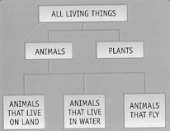

A dichotomous key has a choice of two characteristics at each level.

e.g. Consider a key to group buttons.

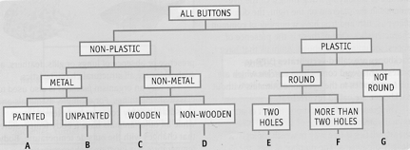

ANIMALS

Biologists use various characteristics to classify animals.

Structural characteristics - backbone or not, number of legs, presence/absence of
lungs or gills, body covering (hair, dry or wet scales,
feathers, moist skin, shell or not).

Functional characteristics - constant body temperature or not (warm or cold-
blooded).

